**M1**

**Introduction**

In this assignment, I am going to name the features and functions of different operating systems. Comparing different operating systems (e.g. LINUX, Windows, DOS, MAC OS) you should cover common features e.g. ability to customize, support for connectivity of portable media, security, stability and reliability, ease of management, associated utilities, cost and support for the user; summarising their respective strengths and weaknesses.

|  |  |  |
| --- | --- | --- |
| **Operating System** | **Features** | **Image** |
| **Windows** | The features for Windows is that the **start screen** differs from other Windows. This is the latest Windows and it shows all the applications that you can use on the computer. By browsing Mail, you can check your emails. In addition, you can split the screen and work on two applications at the same time.  In addition, you have the **ability to customize** the theme/colour of the desktop and the start screen. It comes in any colours and designs.  The **security** for Windows differs from each operating system. From Windows XP – 7, they have included a password to log into the account. Windows 8 has that option but includes a four-digit pin. Both of them are safe as long as it is not easy to figure out. Having an anti-virus is important as it reminds you when you need to scan for viruses. This supports the computer as it can detect any viruses and delete them of the computer. | http://www.bleepstatic.com/tutorials/windows-8/pin-password/enter-pin.jpg |
| **LINUX** | In addition, Linux has many capabilities, which allow people to **create their own layout** like the picture shown, which also allows the user to set the operating system to his needs that windows 7 cannot do which makes it less desirable to some people.  In addition, Linux has features that allow you to code more **efficiently** then windows 7 because it is created for people who want to code and learn more about operating systems but windows 7 does not allow users to do this. | File:Ubuntu 11.10 Final.png |
| **MAC OS** | The **toolbar** differs from other operating systems. It has all the main, common programs right at the bottom, middle of the desktop.  As all the operating systems, it allows you to **multitask** - to use more than one document at the same time. | http://images.apple.com/euro/osx/d/screens_en/whats-new/images/galleries/icloud_keychain_password.jpg  http://images.apple.com/euro/osx/d/screens_en/whats-new/images/galleries/icloud_keychain_password.jpg |

**Comparing Windows and LINUX**

On Linux, **multi-tasking** is not one of the key features because it is made for working two programs at once. It is used on supercomputers and mobile devices which you do not need to multitask as much as Windows 7. Multi-tasking on Windows 7 is one of the features that make it different from Linux and which makes people want to buy it, which is why it is one of the best operating systems. You can use many programs at once e.g. you can use the Internet Browser and Microsoft word at the same time. This image below relates to multi-tasking as it shows you can use more than one application at a time.

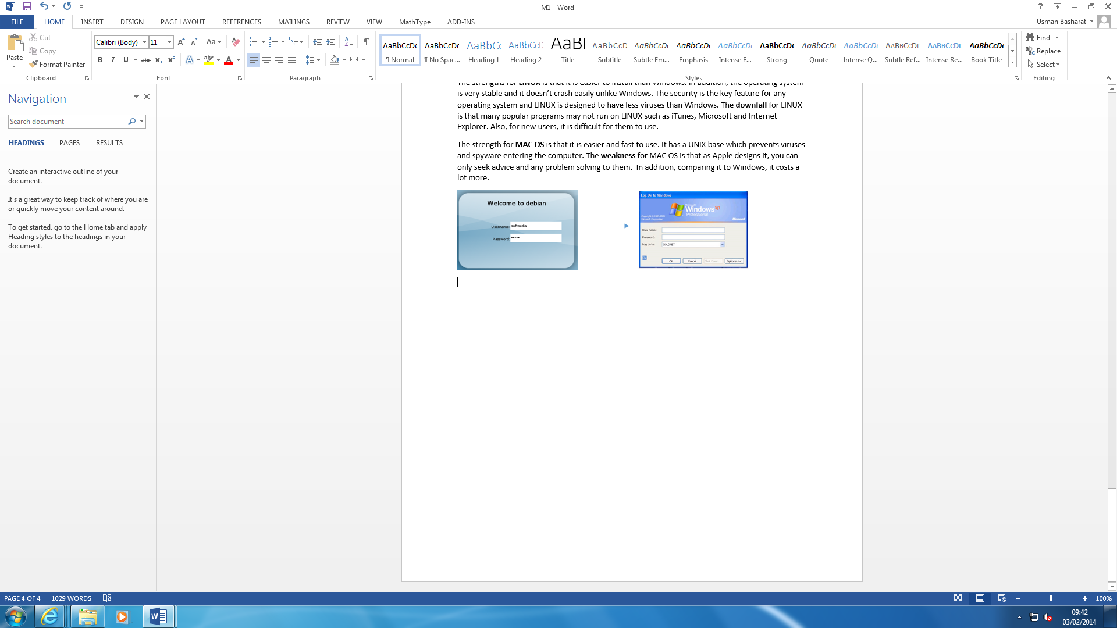The **security** on both Linux and Windows is similar. They both have ways of tracing down viruses and hackers. It is up to the user to keep a secure password so that not any other person can access their account. Linux is versatile as you can create your own layout. The compatibility on both operating systems is very good buy Windows 7 is the best operating for compatibility. This is because it was one of the first operating systems and most developers have created software for Windows 7. Whereas, Linux is not widely used with games and other software.

**[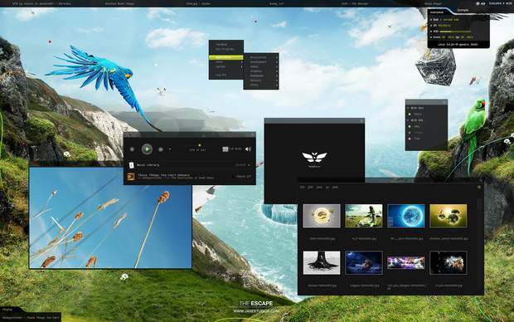](http://www.google.co.uk/url?sa=i&rct=j&q=&esrc=s&frm=1&source=images&cd=&cad=rja&docid=f0LjSXMZUwm9GM&tbnid=FoKTNYz0xdPNkM:&ved=0CAUQjRw&url=http%3A%2F%2Fwww.junauza.com%2F2010%2F10%2F20-really-awesome-linux-desktop.html&ei=H2LvUqLBMM6k0AXF5IHYCA&bvm=bv.60444564,d.ZG4&psig=AFQjCNF5xVIwRvdtffM5_dQjZG2gfA_3iA&ust=1391506276408074)Accessibility** on the Linux is very good because there are no folders and you can access everything from one menu whereas on Windows 7, you have to go to folders and sub folders where you find stuff and when you want to search for the thing your finding, it is very slow as well. Linux is very good on accessibility because it needs to be fast to work with super computers and people like fast operating systems. As the image below shows all the files and programmes that have been saved. It doesn’t take long for the user to update their current work.

**Ability to customize** for Windows 7 is different to LINUX. LINUX, you can actually change the layout of the screen whereas Windows 7 you can change the colour, theme and background wallpaper. Windows only shows a desktop background with applications that you can use. Referring to the image on the left, it shows how it can differ.

**Summary of strength and weaknesses**

The strengths for **Windows** is that overtime it ensures to be better than the old one. Windows 7 has drastic improvements as the main key feature of Window’s strength it is slightly faster each time they make a new Windows operating system. On the downside, the **weakness** for Windows is that the popularity means that more viruses, worms and Trojan horses can be detected on Windows than any other operating system. The more people that use the system, it may have more viruses detected into the computer.

The strengths for **LINUX** is that it is easier to install than Windows. In addition, the operating system is very stable and it doesn’t crash easily unlike Windows. The security is the key feature for any operating system and LINUX is designed to have less viruses than Windows. The **downfall** for LINUX is that many popular programs may not run on LINUX such as iTunes, Microsoft and Internet Explorer. Also, for new users, it is difficult for them to use.

The strength for **MAC OS** is that it is easier and fast to use. It has a UNIX base which prevents viruses and spyware entering the computer. The **weakness** for MAC OS is that as Apple designs it, you can only seek advice and any problem solving to them. In addition, comparing it to Windows, it costs a lot more.

**Customer Reviews**

**Windows**

“Windows 8 is Excellent; I got use to it in half an hour. If you're an experienced Computer user and can't figure it out, give up Computing!”

**Swingarm**

<http://www.techradar.com/reviews/pc-mac/software/operating-systems/windows-8-1093002/review>

**LINUX**

“I have been using Linux for 5 years with no virus, malware, hydra, or worm problems.  
Never crashes and offers free updates from Ubuntu Website.”

<http://www.amazon.com/Ubuntu-Linux-Operating-Virtually-Virus-Proof/product-reviews/B001IK166S>

**MAC OS**

“Just what I needed. Excellent quality and options, great little bit of software”

[**http://store.apple.com/uk/reviews/D3380Z/A/quicktime-7-pro-for-mac-os-x**](http://store.apple.com/uk/reviews/D3380Z/A/quicktime-7-pro-for-mac-os-x)

*Above are customer’s reviews on how they thought of each operating system.*